PRODUCE PROJECT CREW APPLICATION
The Produce Project, established in 2009 in partnership with the Troy School District, grows future leaders right in our backyard. The Produce Project helps participants create their own bridge between dreams and reality, providing skills-based education and a platform for students to re-imagine their communities as they would build them. While the Produce Project has a strong service component, students are not volunteers. Providing our students with stipends affirms that students’ work and time are valuable and valued. From every-day components—such as sending fresh foods home to share with families or providing students a healthy snack after school—to touring local colleges, Capital Roots invests in our participants as they invest in their community.
Please fill out the information to the best of your ability. Return to the Guidance Office or to Capital Roots, 594 River Street, Troy. Make sure you include your contact information!

TELL US ABOUT YOU:

Full Name:_____________________________________________________________
First Middle initial Last

Home Address:_________________________________________________________________

City:____________________________ State:_______ ZIP:________

Home Telephone: (_____) ____________________Cell Telephone (_____) _________________

Email Address:__________________________________________________________________

Current Age:__________ Gender: ________

SCHOOL INFORMATION:

Current Grade Level: 9 10 11 12 Do you attend Questar? Yes No

How did you learn about the Produce Project? _____________________________________________________

Guidance Counselor: ________________________ Science Teacher: ____________________________

PARENT/GUARDIAN INFORMATION:

Parent/Guardian Name: ______________________ Telephone: (____) ________________

Email Address:_________________________________________________________________

This person is my: Legal Guardian Mother Father Relative __________________

For spring consideration, please submit your application by Jan 17th.

REFERENCE INFORMATION*:

Name: ____________________________________________________________________________

Title: ____________________________ Organization/School: ____________________________

Address: __________________________________ Telephone: (_____) _____________________

How long has this person known you? Years___________ Months________________

In what capacity does this person know you?

Job Supervisor/Employer Clergy High School Teacher or Counselor

Volunteer Supervisor Coach Other (specify):_________________________

*For your reference, be sure to ask an adult who knows you well in a professional setting, but is not in your family (ex: a teacher). Explain to them why you want to work for the Produce Project and make sure they know we may give them a call.

APPLICATION QUESTIONS

We want to know who you are! Think carefully about your personal answers to these questions. Write as completely as you can, and try to use all of the space provided. You may attach a separate sheet if you need more room.

- Why do you want to be a member of the Produce Project? What will you bring to the program?

2. Tell us about your goals after high school. How will being in this program help?

- What do you think will be your biggest challenge working at The Produce Project this year?
What do you think will be your unique contribution to the program?

- What do you want to get out of this experience? What do you want to get out of being a part of the Produce Project?

- What time of year are you most available to work with the Produce Project – spring, summer, or fall? If you are not hired for this semester, would you like to be considered for other semesters?

6. Tell about a time when you helped a friend, family member, or someone in your community. What was the situation and what did you do? How did you feel about it?

Thank you! If there is anything else you would like us to know, feel free to attach another sheet of paper.

Questions? Call (518) 312-2295 or (518) 274-8685
And ask for Peter Boyles

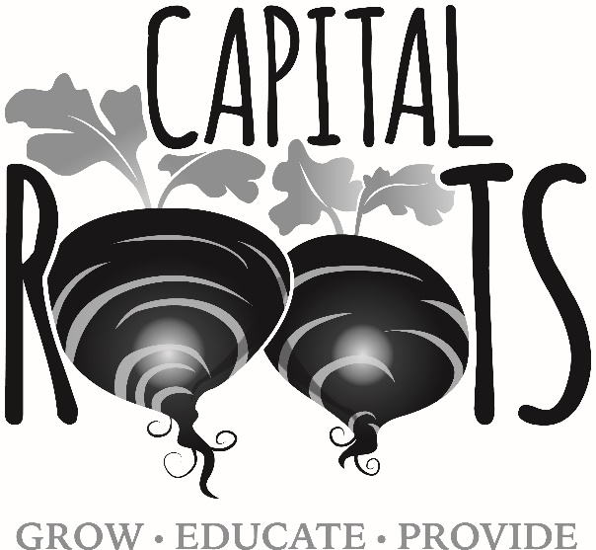

Capital Roots’ mission is to nourish healthy communities by providing access to fresh food and green spaces for all.

